**PSO Project**

**Biocompress Algorithm:**

Here's a comprehensive explanation of Biocompress, an algorithm designed for compressing DNA sequences:

Key Features:

* Lempel-Ziv-based: It builds upon the Lempel-Ziv (LZ) family of compression techniques, specifically LZ77.
* Tailored for DNA: It leverages the unique characteristics of DNA sequences, such as repetitive patterns and palindromes, to achieve enhanced compression.
* Lossless compression: It ensures the original DNA sequence can be perfectly reconstructed from the compressed data.

Algorithm Steps:

1. Initialization:
   * Create a dictionary to store previously encountered substrings.
   * Initialize a buffer to hold the current sequence being processed.
2. Scanning the Sequence:
   * Iterate through the DNA sequence, one symbol (base) at a time.
   * For each symbol:
     + Check if the buffer plus the new symbol form a substring already present in the dictionary:
       - If so, encode the substring by its index in the dictionary and clear the buffer.
     + Otherwise, add the new symbol to the buffer.
3. Encoding Substrings:
   * Substrings found in the dictionary are encoded using two values:
     + Length: The number of symbols in the substring.
     + Distance: The offset from the current position in the sequence to the previous occurrence of the substring.
4. Handling Palindromes:
   * Biocompress also efficiently encodes palindromes (sequences that read the same backward as forward).
   * It detects palindromes and represents them using their length and offset.

Additional Features:

* Arithmetic Coding: Biocompress-2, an enhanced version, incorporates *order-2 arithmetic coding* for further compression of non-repetitive regions.

Benefits:

* Reduced storage requirements: Compresses DNA sequences significantly, saving valuable storage space.
* Faster transmission: Smaller compressed files can be transmitted more efficiently over networks.
* Improved data analysis: Compressed sequences can still be analyzed using specialized tools, enabling efficient research.

Applications:

* Bioinformatics research, where handling large-scale DNA sequences is common.
* DNA sequencing databases, where compression reduces storage costs and facilitates data sharing.
* Personalized medicine, where DNA analysis is increasingly used for diagnosis and treatment.

\***\* order-2 Arithmetic coding \*\***

Here's an explanation of order-2 arithmetic coding:

General Context of Arithmetic Coding:

* It's a lossless data compression technique that surpasses typical methods like Huffman coding in terms of compression efficiency.
* It maps an entire message to a single number (a fraction between 0 and 1) rather than encoding symbols individually.
* This enables it to adapt to the actual probabilities of symbols within the message, leading to better compression.

Key Concept of Order:

* The "order" in arithmetic coding refers to the number of previous symbols that influence the probability of the current symbol being encoded.
* Higher-order models capture more complex dependencies within the data, potentially improving compression.

Order-2 Arithmetic Coding:

* It's a type of arithmetic coding that uses a context of length 2, meaning the probability of the current symbol depends on the two symbols that precede it.
* It involves:
  + A model that estimates the probability of each symbol based on the two previous symbols.
  + An encoding process that maps the message to a fraction within a narrowing interval, iteratively adjusting the interval based on the probabilities of the symbols.
  + A decoding process that reconstructs the original message from the encoded fraction.

Example:

* Consider encoding the string "ABAAB" with order-2 arithmetic coding:
  + The probability of "B" after "AA" might be different from the probability of "B" after "AB".
  + The model captures these contextual dependencies.

Advantages:

* Often achieves better compression than order-0 or order-1 arithmetic coding, especially for data with strong short-range dependencies.

Trade-offs:

* Increased model complexity and computational cost.
* Requires accurate probability estimation for the symbol pairs.

Practical Considerations:

* Order-2 arithmetic coding is used in various compression algorithms, including those for text, images, and audio.
* It's often combined with other techniques like context modeling and adaptive probability estimation to further enhance compression performance.

**LZ Encoding:**

LZ encoding, often referred to as LZ77 encoding, is a lossless data compression technique that identifies and replaces recurring patterns with references to their earlier occurrences. It's named after its inventors, Abraham Lempel and Jacob Ziv, who published it in 1977.

Here's a simplified explanation of how LZ encoding works:

1. Scanning and Matching:
   * The encoder scans the input data sequentially.
   * For each new symbol (character or byte), it searches for the longest matching sequence that has already appeared in the data.
   * This search is typically performed within a limited search buffer, which stores a portion of the recently processed data.
2. Generating Phrases:
   * If a match is found, the encoder creates a phrase that represents the repetition:
     + It records a pointer to the earlier occurrence of the sequence in the data.
     + It also records the length of the matching sequence.
     + For any unmatched symbols, it simply records them as literals.
3. Outputting Phrases:
   * The encoder outputs a series of phrases, each containing either a pointer-length pair for a matching sequence or a literal symbol.

Key Advantages:

* Lossless: LZ encoding preserves all original data without any information loss.
* Effective for repetitive data: It excels in compressing text, code, and other data with recurring patterns.
* Adaptive: It can adjust to different data types and distributions.
* Relatively fast: It offers a good balance between compression efficiency and speed.

Example:

Here's a visualization of how LZ encoding might compress the text "ABAABABACABA":

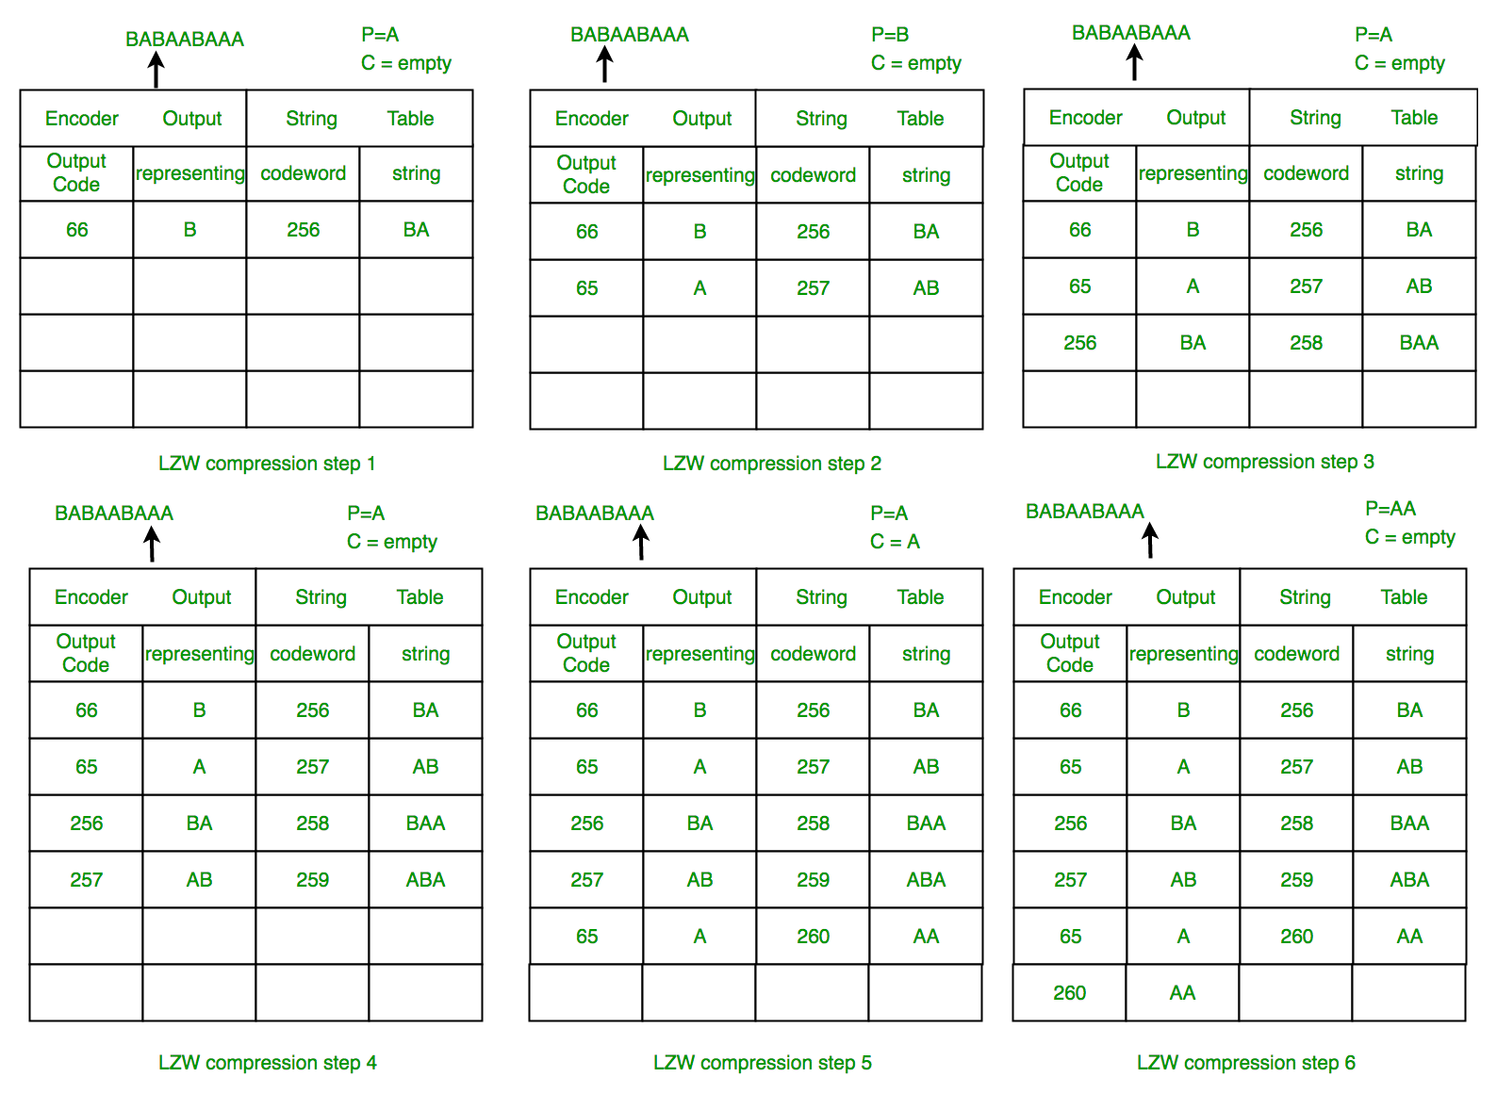

Common Variations:

* LZ78: Another variant by Lempel and Ziv, using a dictionary-based approach.
* LZW: Lempel-Ziv-Welch, a popular variant often used in image compression (GIF).
* LZMA: Lempel-Ziv-Markov chain algorithm, offering high compression ratios.

Applications:

* File compression formats (ZIP, RAR, 7z, PNG, etc.)
* Data transmission protocols (modems, networking)
* Text compression in databases and search engines
* Image compression (GIF)
* DNA sequence compression
* Many other compression-related tasks

**GenCompress:**

**Key Idea:**

- GenCompress focuses on exploiting **approximate repeats** within DNA sequences. It finds similar, but not necessarily identical, patterns that can be compressed more efficiently than exact matches.

**Algorithm Steps:**

1. **Preprocessing:**

- Scans the sequence to identify potential approximate repeats.

- Uses a technique called a "suffix tree" to efficiently locate these patterns.

Suffix tree img:

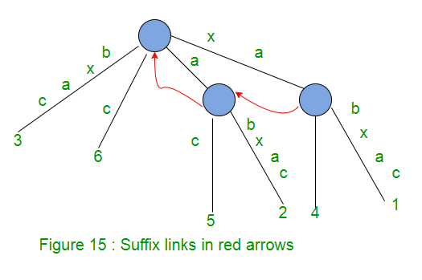

2. **Compression:**

- For each approximate repeat found:

- Encodes the first occurrence of the pattern as-is.

- For subsequent occurrences:

- Records the position of the matching pattern in the sequence.

- Stores any differences (mismatches or insertions/deletions) relative to the first occurrence.

3. **Decompression:**

- Reconstructs the original sequence by:

- Decoding the first occurrences of patterns.

- Applying the recorded differences to generate subsequent occurrences.

**Example:**

Consider a DNA sequence:

```

ACTGTACGTACGTACGCTAGCT

```

- GenCompress might first identify the approximate repeat "ACGT" occurring three times with slight variations:

- `ACTGTACGT` (first occurrence)

- `ACGTACG` (second occurrence, missing "T" at the end)

- `ACGTACGC` (third occurrence, with an added "C" at the end)

- It would then compress the sequence as follows:

ACTGTACGT + (position of second occurrence) + (missing "T") + (position of third occurrence) + (added "C") + TAGCT

**Key Advantages:**

- **Effective for repetitive sequences:** Approximate repeat detection often leads to higher compression ratios for DNA sequences with many repeats.

- **Lossless compression:** Ensures perfect reconstruction of the original sequence.

**Limitations:**

- **Computational cost:** Identifying approximate repeats can be computationally expensive, especially for longer sequences.

- **Sensitivity to parameters:** The effectiveness depends on the parameters used to define acceptable levels of "approximate" similarity.

**Overall:**

GenCompress offers a valuable approach for compressing DNA sequences, particularly those with significant repetitive patterns. However, it's important to consider its computational cost and parameter tuning when applying it in practical scenarios.

**DNACompress:**

**Here's a simplified explanation of DNACompress:**

**DNACompress is like a master puzzle solver that efficiently packs DNA sequences into smaller spaces.**

**Key Steps:**

1. **Building a frequency table:** DNACompress first counts how often each base (A, C, G, T) appears in the sequence, creating a blueprint for efficient packing.

2. **Rearranging the sequence:** It cleverly rearranges the sequence to put similar bases closer together, like sorting puzzle pieces by color.

3. **Assigning shorter codes:** Using Huffman Coding, it assigns shorter codes to more frequent bases and longer codes to rarer ones.

4. **Finding hidden patterns:** It applies a technique called the Burrows-Wheeler Transform (BWT) to reveal repeating patterns that weren't obvious before.

5. **Compressing the patterns:** It exploits these patterns using run-length encoding, which means saying "this base repeats X times" instead of writing it out repeatedly.

**Example:**

- Original DNA sequence: "ACGTACGTACT"

- DNACompress rearranges it to "AACGTACGTTT" (putting similar bases together).

- It assigns codes like "0" for A, "10" for C, "110" for G, and "111" for T (since A is most frequent).

- It applies BWT to find the repeat "ACGT".

- Compressed version: "0101101110 (repeat twice), add C"

**Key Points:**

- **Highly Effective:** DNACompress achieves excellent compression ratios for DNA sequences due to its combination of techniques.

- **Lossless:** It preserves all information, ensuring perfect reconstruction of the original sequence.

- **Computationally Demanding:** It can be relatively slow compared to simpler methods, but its compression gains often justify the trade-off.

**Why It's Important:**

- **Managing Massive Data:** DNACompress helps handle the ever-growing volume of DNA data in genomics research.

- **Reducing Storage Costs:** It minimizes storage requirements, making it more affordable to store large datasets.

- **Accelerating Analysis:** Compressed data can be processed faster, speeding up analysis tasks.

- **Enabling Data Sharing:** Smaller files are easier to share and transfer, facilitating collaboration and data exchange.

**Context Tree Weighting (CTW):**

Here's an explanation of Context Tree Weighting (CTW) with an example and diagram:

Context Tree Weighting (CTW) is a powerful algorithm for estimating the probability of a sequence of events, taking into account their context or history. It's particularly useful in compression and prediction tasks where understanding the relationships between sequential elements is crucial.

Key Concepts:

* Context Tree: A full binary tree where each node represents a possible context (past sequence) up to a certain depth.
* Weighted Tree: Assigns probabilities to each node based on the observed frequencies of events within that context.
* Recursive Probability Calculation: The probability of the entire sequence is calculated recursively, starting from the leaves and moving towards the root.

Example with Diagram:

1. Building the Context Tree (order 3):

Root (empty context)

/ \

0 1

/ \ / \

0 1 0 1

2. Observing Sequence "0110100":

* Update counts at leaves based on observed events:
  + 00: 2 times
  + 10: 1 time
  + 1: 3 times

3. Weighted Context Tree:

Root: P = ?

/ \

0:P=1/2 1:P=1/2

/ \ / \

0:P=2/3 1:P=1/3 0:P=1/3 1:P=2/3

4. Recursive Probability Calculation:

* Calculate probabilities for internal nodes using a weighted average of child probabilities.
* At the root, the final probability of the sequence "0110100" is obtained.

CTW Advantages:

* Handles long-range dependencies: Captures patterns over extended contexts.
* Adaptive: Adjusts to changes in sequence characteristics.
* Compact representation: Stores only counts, not full probabilities.

Applications:

* Data compression (e.g., CTW+ algorithm)
* Sequence prediction (e.g., language modeling)
* Anomaly detection
* Information theory (e.g., entropy estimation)

**DNAPack:**

DNAPack is a lossless compression algorithm specifically designed for DNA sequences. It was developed by Behshad Behzadi and Fabrice Le Fessant in 2005.

One informative article- https://link.springer.com/chapter/10.1007/11496656_17

Here's a breakdown of its key features and how it works:

1. Dynamic Programming Approach:

Unlike traditional compression algorithms that rely on finding exact repeats, DNAPack employs dynamic programming to identify and efficiently compress both exact and approximate repeats within DNA sequences.

This approach allows it to capture similarities that might be missed by other methods, leading to better compression ratios.

2. Compression Process:

DNAPack divides the DNA sequence into smaller segments.

It then constructs a matrix using dynamic programming to determine the optimal way to represent those segments using a combination of exact and approximate matches.

The resulting compressed file contains the compressed representation of the segments, along with additional information needed for decompression.

3. Advantages:

Achieves better compression ratios than many other DNA compression algorithms, often outperforming them by a small but significant margin.

Computationally efficient, with the cost of dynamic programming being relatively low compared to the overall compression process.

Lossless compression, ensuring that the original DNA sequence can be fully recovered without any loss of information.

4. Availability:

The DNAPack algorithm is available as open-source software on Fabrice Le Fessant's website.

It can be compiled and run on GNU-Linux/x86 platforms.

5. Applications:

DNAPack is primarily used for compressing large DNA sequence databases to reduce storage requirements and facilitate faster data transmission.

It's also valuable in research settings where compression of DNA sequences is needed for analysis and comparison.

Here's a detailed explanation of the main algorithm used in DNAPack:

1. Preprocessing:

The input DNA sequence is divided into smaller blocks of a fixed size (typically 100 nucleotides).

A suffix array is constructed for the entire sequence, which efficiently stores all possible suffixes of the sequence in lexicographic order. This allows for fast identification of matches and repeats.

2. Dynamic Programming Matrix Construction:

A two-dimensional matrix is created, where each cell (i, j) represents the minimum cost of encoding the subsequence from position i to position j.

The cost is calculated based on the following factors:

The length of the subsequence.

The number of exact and approximate matches found within the subsequence.

The position of the matches within the subsequence.

3. Optimal Encoding Search:

The algorithm dynamically fills the matrix, starting from the smallest subsequences and gradually progressing to larger ones.

At each cell (i, j), it explores different encoding options:

Using an exact match from a previously encoded subsequence.

Encoding the subsequence as a new string.

Dividing the subsequence into smaller segments and encoding them separately.

The algorithm chooses the option that results in the lowest cost.

4. Encoding and Compression:

Once the optimal encoding for the entire sequence is determined, it's written to the compressed file.

This includes:

The encoded segments.

Information about the positions of matches and repeats.

Additional metadata for decompression.

5. Decompression:

The decompression process reverses the steps of compression.

It reads the encoded segments and match information from the compressed file.

It uses the dynamic programming matrix to reconstruct the original DNA sequence.

DNAPack is a lossless compression algorithm specifically designed for DNA sequences. It was developed by Behshad Behzadi and Fabrice Le Fessant in 2005.

One informative article- https://link.springer.com/chapter/10.1007/11496656_17

Here's a breakdown of its key features and how it works:

1. Dynamic Programming Approach:

Unlike traditional compression algorithms that rely on finding exact repeats, DNAPack employs dynamic programming to identify and efficiently compress both exact and approximate repeats within DNA sequences.

This approach allows it to capture similarities that might be missed by other methods, leading to better compression ratios.

2. Compression Process:

DNAPack divides the DNA sequence into smaller segments.

It then constructs a matrix using dynamic programming to determine the optimal way to represent those segments using a combination of exact and approximate matches.

The resulting compressed file contains the compressed representation of the segments, along with additional information needed for decompression.

3. Advantages:

Achieves better compression ratios than many other DNA compression algorithms, often outperforming them by a small but significant margin.

Computationally efficient, with the cost of dynamic programming being relatively low compared to the overall compression process.

Lossless compression, ensuring that the original DNA sequence can be fully recovered without any loss of information.

4. Availability:

The DNAPack algorithm is available as open-source software on Fabrice Le Fessant's website.

It can be compiled and run on GNU-Linux/x86 platforms.

5. Applications:

**DNAPack:**

DNAPack is a lossless compression algorithm specifically designed for DNA sequences. It was developed by Behshad Behzadi and Fabrice Le Fessant in 2005.

One informative article- https://link.springer.com/chapter/10.1007/11496656_17

Here's a breakdown of its key features and how it works:

1. Dynamic Programming Approach:

Unlike traditional compression algorithms that rely on finding exact repeats, DNAPack employs dynamic programming to identify and efficiently compress both exact and approximate repeats within DNA sequences.

This approach allows it to capture similarities that might be missed by other methods, leading to better compression ratios.

2. Compression Process:

DNAPack divides the DNA sequence into smaller segments.

It then constructs a matrix using dynamic programming to determine the optimal way to represent those segments using a combination of exact and approximate matches.

The resulting compressed file contains the compressed representation of the segments, along with additional information needed for decompression.

3. Advantages:

Achieves better compression ratios than many other DNA compression algorithms, often outperforming them by a small but significant margin.

Computationally efficient, with the cost of dynamic programming being relatively low compared to the overall compression process.

Lossless compression, ensuring that the original DNA sequence can be fully recovered without any loss of information.

4. Availability:

The DNAPack algorithm is available as open-source software on Fabrice Le Fessant's website.

It can be compiled and run on GNU-Linux/x86 platforms.

5. Applications:

DNAPack is primarily used for compressing large DNA sequence databases to reduce storage requirements and facilitate faster data transmission.

It's also valuable in research settings where compression of DNA sequences is needed for analysis and comparison.

Here's a detailed explanation of the main algorithm used in DNAPack:

1. Preprocessing:

The input DNA sequence is divided into smaller blocks of a fixed size (typically 100 nucleotides).

A suffix array is constructed for the entire sequence, which efficiently stores all possible suffixes of the sequence in lexicographic order. This allows for fast identification of matches and repeats.

2. Dynamic Programming Matrix Construction:

A two-dimensional matrix is created, where each cell (i, j) represents the minimum cost of encoding the subsequence from position i to position j.

The cost is calculated based on the following factors:

The length of the subsequence.

The number of exact and approximate matches found within the subsequence.

The position of the matches within the subsequence.

3. Optimal Encoding Search:

The algorithm dynamically fills the matrix, starting from the smallest subsequences and gradually progressing to larger ones.

At each cell (i, j), it explores different encoding options:

Using an exact match from a previously encoded subsequence.

Encoding the subsequence as a new string.

Dividing the subsequence into smaller segments and encoding them separately.

The algorithm chooses the option that results in the lowest cost.

4. Encoding and Compression:

Once the optimal encoding for the entire sequence is determined, it's written to the compressed file.

This includes:

The encoded segments.

Information about the positions of matches and repeats.

Additional metadata for decompression.

5. Decompression:

The decompression process reverses the steps of compression.

It reads the encoded segments and match information from the compressed file.

It uses the dynamic programming matrix to reconstruct the original DNA sequence.

**Dynamic Network Anomaly Detection Protocol (DNADP):**

Purpose:

Detects anomalies in real-time network traffic to identify potential threats and attacks.

Aims to protect networks from intrusions, malware, data breaches, and other cybersecurity risks.

Key Features:

Dynamic thresholding: Adjusts thresholds for identifying anomalies based on current network conditions, ensuring responsiveness to changes.

Machine learning techniques: Employs machine learning to model normal network behavior and detect deviations that signal potential threats.

Adaptability: Continuously learns and adapts to evolving network patterns, making it resilient to new attack methods.

Real-time analysis: Processes network traffic in real-time to enable immediate threat detection and response.

General Process:

Data Collection: Gathers network traffic data, including packet headers, payloads, flow information, and other relevant metrics.

Feature Extraction: Extracts meaningful features from the traffic data, such as source/destination IP addresses, port numbers, protocols, traffic volumes, and time-based patterns.

Modeling Normal Behavior: Uses machine learning techniques to create a baseline model of normal network behavior, capturing patterns and statistical properties.

Anomaly Detection: Compares incoming traffic to the normal behavior model and flags any significant deviations as potential anomalies.

Threat Classification: Further analyzes anomalies to classify them as benign or malicious, using techniques like signature matching, rule-based analysis, or behavioral analysis.

Alert Generation: Triggers alerts for potential threats, providing information to security analysts for investigation and response.

Common Applications:

Intrusion detection systems (IDS)

Network security monitoring (NSM)

Fraud detection

Network performance monitoring

Anomaly-based intrusion detection

Benefits:

Early detection of threats

Reduced false positives

Improved adaptability to changing network conditions

Enhanced network visibility

Potential for automated response

Drawbacks and Considerations:

Complexity of implementation and maintenance

Potential for false positives

Need for continuous training and updating

Resource requirements for real-time analysis

**ScPSO:**

Here's a comprehensive explanation of the Scout Particle Swarm Optimization (ScPSO) algorithm:

Key Concepts:

* Inspiration: It draws inspiration from both Particle Swarm Optimization (PSO) and the scout bee behavior in honey bee colonies.
* Purpose: It's designed to enhance the exploration and exploitation capabilities of PSO, aiming for more robust and efficient global optimization.

Key Features:

1. Scout Bee Phase:
   * Periodically, particles with poor fitness become scouts.
   * Scouts abandon their current positions and explore new, random areas of the search space.
   * This promotes diversity and helps prevent premature convergence.
2. Swarming Phase:
   * Particles update their positions based on their own best experiences (pbest) and the global best experience (gbest), as in standard PSO.
   * However, ScPSO employs a modified velocity update equation to balance exploration and exploitation.

Algorithm Outline:

1. Initialization:
   * Define problem parameters and constraints.
   * Initialize a population of particles with random positions and velocities.
   * Evaluate the fitness of each particle.
2. Iterative Process:
   * Scout Bee Phase:
     + Identify particles with poor fitness as scouts.
     + Replace their positions with random new positions within the search space.
   * Swarming Phase:
     + Update velocities and positions of particles using the modified PSO equation.
     + Evaluate the fitness of the new particles.
     + Update pbest and gbest values.
3. Termination:
   * Repeat the process until a stopping criterion is met (e.g., maximum iterations, desired fitness level).

Advantages:

* Improved Exploration: The scout bee phase effectively prevents premature convergence and enhances exploration of the search space.
* Balanced Exploration-Exploitation: The modified velocity update equation balances the need to explore new areas with the need to exploit promising regions.
* Robustness: ScPSO has been shown to be more robust to local optima than standard PSO, especially for complex optimization problems.

Applications:

* Continuous optimization problems in various fields, including:
  + Engineering design
  + Machine learning
  + Image processing
  + Power system optimization
  + Economic scheduling
  + And more